Event promoted for and on behalf of Cycling Time Trials
under its Rules and Regulations

Darlington CC 25 MILE Time Trial
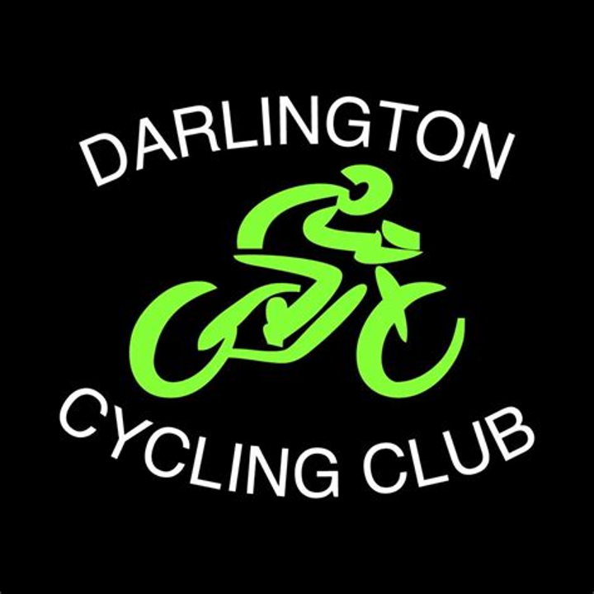


Sunday 6th October 2024 – Results

Thanks for entering our event. The weather managed to stay dry which is always a bonus! Well done to all our riders, some good times on a lumpy course in less than ideal conditions.

Open

First Alex Beldon Team Bottrill
Second Matt Chipping Leeds & Bradford Tri Club
Third Ellis Murray Darlington CC

Female

First Angela Hannon-Flaherty Seacroft Wheelers
Second Deborah Jeffries Manilla CC

Road bike

First Neil Turner Endurance Academy
Second Dean Bowmer Barnsley Road Club
Third Howard Heighton Ferryhill Wheelers

Team

First Harrogate Nova CC

Please come and join us again in 2025 when we plan to organise;

- A Hill Climb
- A race over two laps of a 6.25 mile circuit for solos and 2-ups!
- A 10 mile TT
- A 25 mile TT

Thanks again to the members of Darlington CC for supporting the event

EVENT SECRETARY Steven Madeley
Honeysuckle House, 3 Falcon Walk, Hilton TS15 9JB
Mobile: 07710 014508
email: steven@smcs.wales

